1. Six sigma definitions:

* Six Sigma is lots of different things because it had different meanings over time, and also because it is now interpreted in increasingly different ways. And Six Sigma is still evolving.
* Six Sigma is a measure of the number of defects in a specific process or operation. Six Sigma is a set of strategies, techniques, and tools for process improvement. we think about Six Sigma at three different levels:
* As a metric
* As a methodology
* As a management system
* Essentially, Six Sigma is all three at the same time.
* Following six sigma according to general electric: Six Sigma is a highly disciplined process that helps us focus on developing and delivering near-perfect products and services. Why 'Sigma'? The word is a statistical term that measures how far a given process deviates from perfection. The central idea behind Six Sigma is that if you can measure how many 'defects' you have in a process, you can systematically figure out how to eliminate them and get as close to 'zero defects' as possible. To achieve Six Sigma Quality, a process must produce no more than 3.4 defects per million opportunities. An 'opportunity' is defined as a chance for nonconformance, or not meeting the required specifications. This means we need to be nearly flawless in executing our key processes."
* Six Sigma revolves around a few key concepts.
* Critical to Quality: Attributes most important to the customer
* Defect: Failing to deliver what the customer wants
* Process Capability: What your process can deliver
* Variation: What the customer sees and feels
* Stable Operations: Ensuring consistent, predictable processes to improve what the customer sees and feels
* Design for Six Sigma: Designing to meet customer needs and process capability.

1. History: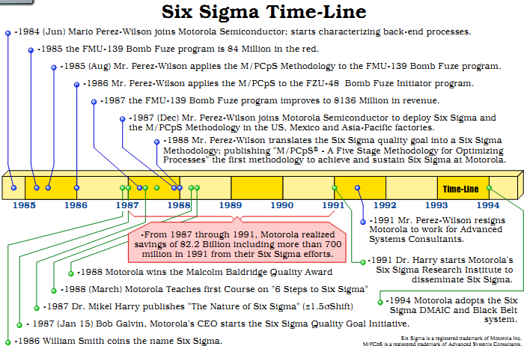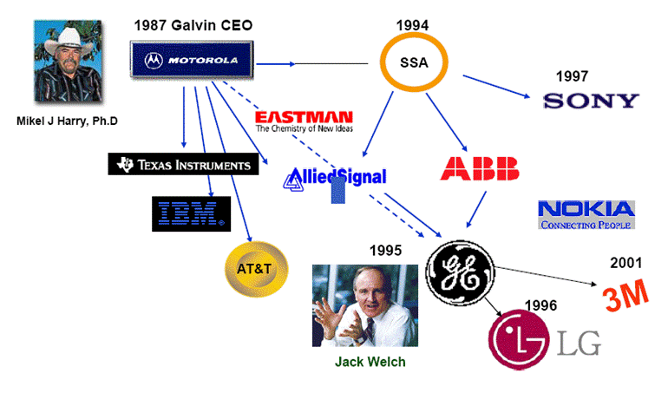
2. Role and Responsibility:

* One key innovation of Six Sigma involves the absolute "professionalizing" of quality management functions. Prior to Six Sigma, quality management in practice was largely relegated to the production floor and to [statisticians](http://en.wikipedia.org/wiki/Statistician) in a separate quality department. Formal Six Sigma programs adopt a kind of elite ranking terminology (similar to some martial arts systems, like Kung-Fu and Judo) to define a hierarchy (and special career path) that kicks across all business functions and levels.
* Six Sigma identifies several key roles for its successful implementation.
* **Executive Leadership:** includes the CEO and other members of top management. They are responsible for setting up a vision for Six Sigma implementation. They also empower the other role holders with the freedom and resources to explore new ideas for breakthrough improvements.
* **Champions:**take responsibility for Six Sigma implementation across the organization in an integrated manner. The Executive Leadership draws them from upper management. Champions also act as mentors to Black Belts.
* **Master Black Belts:** identified by champions, act as in-house coaches on Six Sigma. They devote 100% of their time to Six Sigma. They assist champions and guide Black Belts and Green Belts. Apart from statistical tasks, they spend their time on ensuring consistent application of Six Sigma across various functions and departments.
* **Black Belts:** operate under Master Black Belts to apply Six Sigma methodology to specific projects. They devote 100% of their valued time to Six Sigma. They primarily focus on Six Sigma project execution and special leadership with special tasks, whereas Champions and Master Black Belts focus on identifying projects/functions for Six Sigma.
* **Green Belts:** are the employees who take up Six Sigma implementation along with their other job responsibilities, operating under the guidance of Black Belts.
* **Team members:** Provide the everyday requirements for execution of the DMAIC model. They also help spread the word about six sigma tools and processes and ultimately they become part of the reservoir of human resources available for future projects.
* **Process owner:** This person takes on a new, cross-functional responsibility to manage all the steps that provide value to the internal as well as external customer. The sponsor and the process owner may be the same person.
* Some organizations use additional belt colours, such as Yellow Belts, for employees that have basic training in Six Sigma tools and generally participate in projects and "White belts" for those locally trained in the concepts but do not participate in the project team. "Orange belts" are also mentioned to be used for special cases.

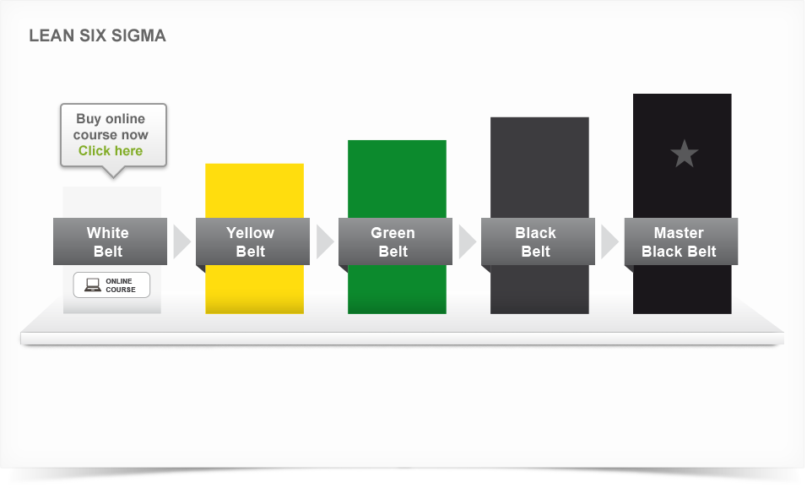

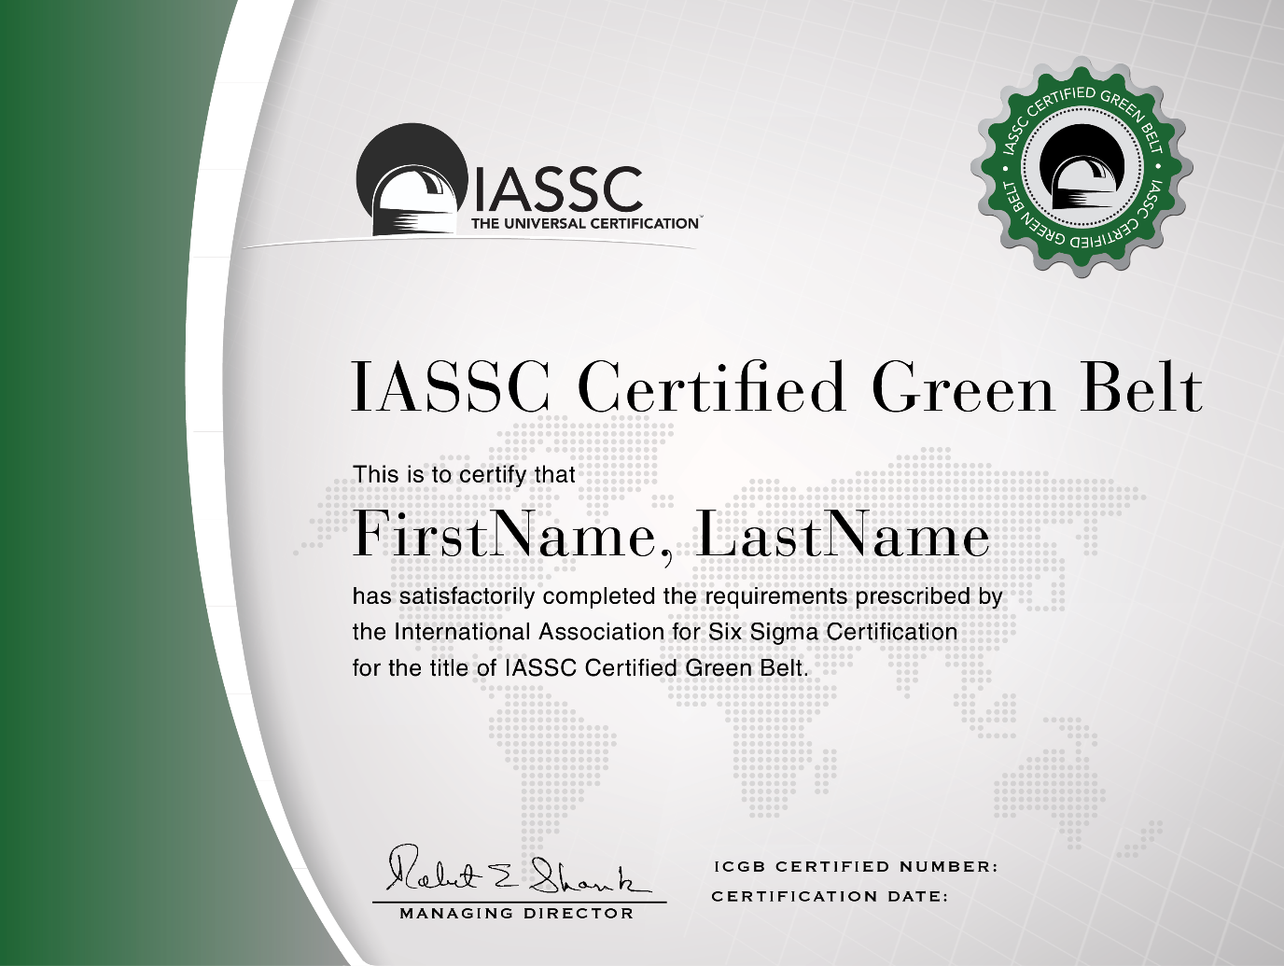

1. Why Six Sigma is Important

* Most companies operate at three or Four Sigma. That means the losses they incur as a result of poor quality cost them 10 to 15 percent of their revenue. A company operating at Six Sigma. However, can generate considerable savings. According to one source, the savings as a percentage of revenue vary from 1.2 percent to 4.5 percent [source: I Six Sigma]. That means a company with revenues of $1 million could save up to $45,000, and a company with revenues of $1 billion could save up to $45,000,000.

1. Area application

* Six Sigma is an “Industry Independent” methodology and has been successfully applied across:
* Manufacturing Industry including Auto motives, Aerospace, Health Equipment, FMCG, Electronic Goods, Continuous process Industries, Textiles, etc.
* Service Industry including Telecom, banking and Financial Services, Health Care, hotels, IT, ITES, KOPs, Airline, Cargo movement, Support Service, HR services, Marketing Service, etc.
* R&D organizations or in R&D function of various organizations for example

Table 1 . Area application of Six Sigma

|  |  |
| --- | --- |
| **Industry** | **Examples of Six Sigma Applicability** |
| Automotive | * Enhancing Supplier Quality * Improving Safety & Reliability of Finished Vehicles * Reducing Manufacturing defects at each stage * Using Design FMEA to understand and prevent any possible design failures * Reducing variation in all the critical parameters that impact the finished product * Improving the overall Incoming Material Quality or parts Quality * Optimizing Inventory levels for all major parts * Reducing time to manufacture * Reducing Design defects * Reducing Supplier Lead time i.e. the time take by each supplier to deliver goods * Improving First time yield and efficiency of each step in the Manufacturing assembly line. |
| Continuous Process Plants | * Improving overall Yield of each shift * Reduce scrap or spilled materials * Reduce the Process failures or breakdowns * Increase Plant capacity utilization * Improve Operator Productivity * Reduce time to restart the process after failure * Create mechanisms to prevent failures at each stage * Improve overall process stability & control |
| Engineering Parts Manufacturing | * Reduce Manufacturing cycle time (time of order to delivery) * Improve Customer Service performance scores * Reduce or optimize inventory levels * Reduce scrap or cost of poor quality * Reduce warranty costs * Reduce rejections due to design errors * Improve parts design process to meet specifications 100% of times * Improve parts reliability by identifying & optimizing critical factors that ensure reliability |
| Information Technology :Software development | * Reducing the overall Software development times * Reducing the number of errors found during product usage * Improving the estimation process to reduce time and cost overruns * Improving the requirements gathering process to reduce rework * Reducing complaints resolution time * Creating systems to detect defects early in the process (to reduce high costs associated with defects identified later) * Reducing appraisal cost per defect by phase and appraisal type (by project and in total) * Reducing rework (All work done to fix an application after it has been delivered to a customer is rework. This includes corrections to features or functions that are incorrect, and also may include "missed requirements" - things the customer expected but did not receive. |
| Telecom | * Improving ARPU (Average revenue per unit) * Reducing Billing errors * Reducing timeliness of billing * Improving the Call Completion rate (i.e Network Quality) * Reducing network congestion * Development of new features, processes for new services * Improving accuracy, timeliness and completeness of new connections * Improving accuracy, timeliness and completeness of customer communication. * Reducing Customer churn * Reducing network congestion * Improving call routing procedures * Improving sales productivity |
| R&D/ Product Design | * Reducing the time to market * Reducing rework through synergy between R&D and the customer facing staff. * Improving the overall performance & quality of product from start * Minimizing product failures by ensuring robust designs * Improving quality of research process & experiments by providing mass education in Experimental design and Multivariate studies * Improving quality of design reviews (data driven reviews) * Reducing defects in final product thereby saving on warranty costs. |

1. Who uses Six Sigma?

* In the early days, Six Sigma was limited to complex manufacturing environments. But today, it has spread into every industry and into every functional area. According to a survey conducted by Quality
* Digest, the distribution of Six Sigma programs is now spread across a growing number of functional areas:
* Manufacturing
* Engineering
* Administration
* Test/Inspection
* Plant operation
* Customer service
* Research/Development
* Purchasing
* Sales/Marketing
* Shipping/Receiving
* Document control
* Pollution prevention
* Still, it’s not right for every company or every process. Many small companies simply lack the resources necessary to implement Six Sigma. And others with the financial resources sometimes don’t have enough support from upper management to get Six Sigma initiatives off the ground.

1. Six Sigma Calculations

* To give such numbers meaning, the engineers at Motorola set up a scale to evaluate the quality of a process based on these defect calculations. At the top of the scale is Six Sigma, which equates to 3.4 DPMO, or 99.9997% defect-free. In other words, if you have a process running at Six Sigma, you've almost eliminated all defects -- it's nearly perfect. Of course, most processes don't run at Six Sigma. They run at Five Sigma, Four Sigma or worse. Here's the full scale to get an appreciation of the numbers involved:
* **Five Sigma** = 233 DPMO, or 99.98% defect-free
* **Four Sigma** = 6,210 DPMO, or 99.4% defect-free
* **Three Sigma** = 66,807 DPMO, or 93.3% defect-free
* **Two Sigma** = 308,538 DPMO, or 69.1% defect-free
* **One Sigma** = 691,462 DPMO, or 30.9% defect-free
* Indeed, as Six Sigma has evolved, it has become closely associated with other business strategy methodologies, such as Balanced Scorecard. That means different people at different times will define Six Sigma quite differently. Some will describe it as a metric, or a measurement of defects. Others will describe it as a methodology, a way to solve problems.

|  |  |  |  |  |  |  |
| --- | --- | --- | --- | --- | --- | --- |
| **Sigma level** | **Sigma (with 1.5σ shift)** | [**DPMO**](http://en.wikipedia.org/wiki/Defects_per_million_opportunities) | **Percent defective** | **Percentage yield** | **Short-term Cpk** | **Long-term Cpk** |
| 1 | -0.5 | 691,462 | 69% | 31% | 0.33 | –0.17 |
| 2 | 0.5 | 308,538 | 31% | 69% | 0.67 | 0.17 |
| 3 | 1.5 | 66,807 | 6.7% | 93.3% | 1.00 | 0.5 |
| 4 | 2.5 | 6,210 | 0.62% | 99.38% | 1.33 | 0.83 |
| 5 | 3.5 | 233 | 0.023% | 99.977% | 1.67 | 1.17 |
| **6** | **4.5** | **3.4** | **0.00034%** | **99.99966%** | **2.00** | **1.5** |
| 7 | 5.5 | 0.019 | 0.0000019% | 99.9999981% | 2.33 | 1.83 |